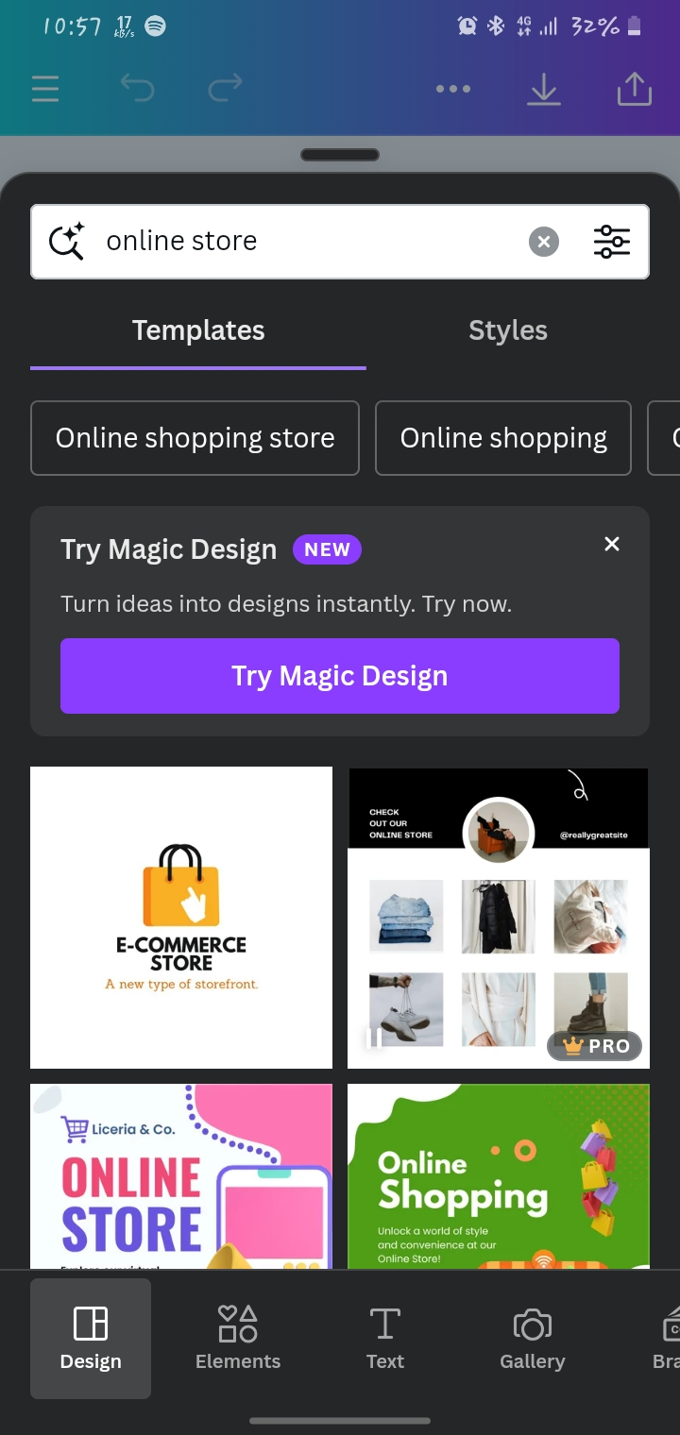**LOGO CREATION STEPS:**

**Step 1:**

**Download and login canva app**

**Search:**

**Logo creation for online store**

**Step 2:**

**Select or create according to your design**

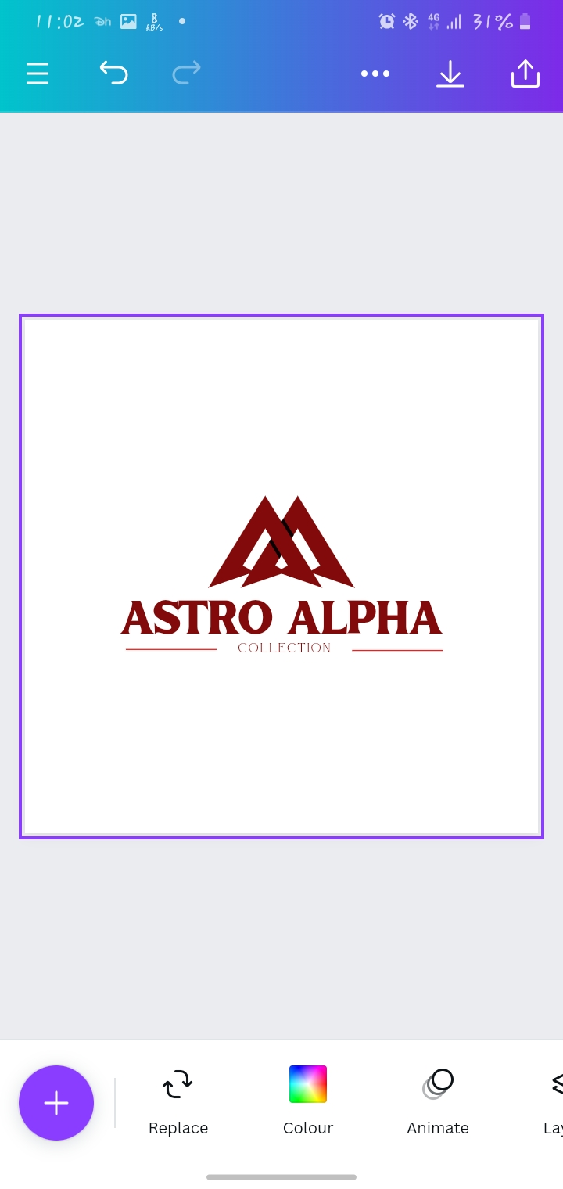

**Step 3:**

**Edit as ‘your brand name’-ASTRO APLHA COLLECTION**

